Sprint 2 - Endurance Design Document

November 20, 2023Table of Contents

1. Executive Summary 3

1.1 Project Overview 3

1.2 Purpose and Scope of this Specification 3

2. Product/Service Description 3

2.1 Product Context 3

2.2 User Characteristics 3

2.3 Assumptions 3

2.4 Constraints 3

2.5 Dependencies 3

3. Requirements 3

3.1 Functional Requirements 3

3.2 Security 4

3.2.1 Protection 4

3.2.2 Authorization and Authentication 4

3.3 Portability 4

4. Requirements Confirmation/Stakeholder sign-off 4

5. System Design 4

5.1 Algorithm 4

5.2 System Flow 5

5.3 Software 5

5.4 Hardware 5

5.5 Test Plan 5

5.6 Task List/Gantt Chart 6

5.7 Staffing Plan 7

# Executive Summary

## Project Overview

This product is designed to move in a figure 8 five times then speak and flash different colors for five seconds, the teacher is the intended audience.

## Purpose and Scope of this Specification

* The intended audience was chosen because that is who is grading this project

# Product/Service Description

Factors that affect the product is the surface that the robot is placed on. If it is a rough or unbalanced surface the robot won’t be able to perform the figure 8 properly. If the battery is low then the robot won’t properly perform the figure 8.

## Product Context

This product is related to other products created by the same company Sphero. It is not independent because in order for the robot to be programmed to move, the Sphero Edu application must be downloaded.

## User Characteristics

* Faculty / Student
* No experience required
* Small amount of technical experience

## Assumptions

There is a computer with the Sphero Edu application downloaded on a computer with bluetooth on it. The person operating the computer must have some understanding on how to boot up and run the program.

## Constraints

* Different software being used to run the code
* Old or damaged models of the robot
* Computer that doesn’t have bluetooth

## Dependencies

* The project must be used on a Mac to show the sensor data
* The floor must be a flat area so that the robot runs properly
* The robot must be on and connected using bluetooth to the Mac computer

# Requirements

* The robot must go in a figure 8 5 times PRIO 1
* Justin is the tester that is going to verify that the system satisfies the requirements
* Once the program starts the robot is going to start moving in the figure 8 shape
* Check to make sure the robot doesn’t create a larger figure 8 then it is supposed to.

## Functional Requirements

| **Req#** | **Requirement** | **Comments** | **Priority** | **Date Rvwd** | **SME Reviewed / Approved** |
| --- | --- | --- | --- | --- | --- |
| ACCUR_01 | Move in a figure 8 | This happens 5 times | 1 | 11/15 | 11/17 |
| ACCUR_02 | say “I am the winner” |  | 3 | 11/15 | 11/17 |
| ACCUR_03 | flash multicolored | this happens for 5 seconds | 2 | 11/15 | 11/17 |
|  |  |  |  |  |  |
|  |  |  |  |  |  |
|  |  |  |  |  |  |
|  |  |  |  |  |  |
|  |  |  |  |  |  |
|  |  |  |  |  |  |

## Security

### Protection

* One person's computer will have the program so no one can access it except the owner of that computer

### Authorization and Authentication

In order to make sure no unauthorized people get access to the program, only the members of the group and professor will be able to see the code.

## Portability

* The Sphero has host-dependent code and it is the only component;
* All written code is dependent on usage of the Sphero;
* The computer must have the Sphero Edu IDE
* The environment around must be a flat surface or else the robot won’t move correctly

# Requirements Confirmation/Stakeholder sign-off

|  |  |  |
| --- | --- | --- |
| **Meeting Date** | **Attendees (name and role)** | **Comments** |
| 11/15/23 | Justin: programmer | Programmed and tested algorithm |
|  |  |  |

# System Design

## Algorithm

* The ball’s speed will be set
* The spin will be set to a full circle (360 degrees)
* Once the circle is completed it will go in reverse and complete the other half of the figure 8
* This is put in a for-loop and iterate 5 times total
* Once the loop is complete it will say “I am the winner!”
* It will then flash multicolored for 5 seconds

## System Flow

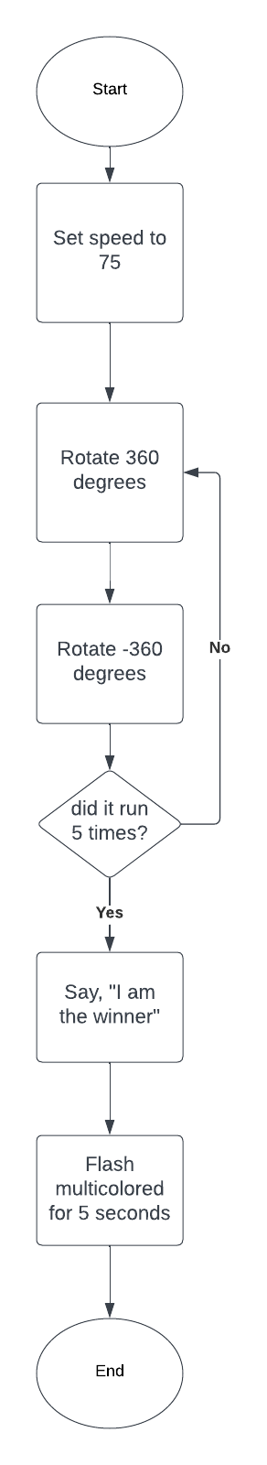

## Software

We used block code as our language on the API, Sphero edu.

## Hardware

We used Mac and windows laptops

## Test Plan

| **Reason for Test Case** | **Test Date** | **Expected Output** | **Observed Output** | **Staff Name** | **Pass/Fail** |
| --- | --- | --- | --- | --- | --- |
| Attempt half of figure 8 | 11/15 | It would go in a circle and stop | the circle it created was too small | Justin | Fail |
| Attempt half of figure 8 | 11/15 | It would go in a circle and stop | the circle it created was too small | Justin | Fail |
| Attempt half of figure 8 | 11/15 | It would go in a circle and stop | Went in perfect circle | Justin | Pass |
| Attempt full figure 8 | 11/15 | it would move in a figure 8 | It went in a figure 8 | Justin | Pass |
| Attempt the figure 8 5 times | 11/15 | Move in a figure 8 five times | at the end of the five loops it was not in the center | Justin | Fail |
| Attempt the figure 8 5 times | 11/15 | Move in a figure 8 five times | at the end of the five loops it was not in the center | Justin | Fail |
| Attempt the figure 8 5 times | 11/15 | Move in a figure 8 five times | at the end of the five loops it was not in the center | Justin | Fail |
| Attempt the figure 8 5 times | 11/15 | Move in a figure 8 five times | Moved in a figure 8 five times and remained in place | Justin | Pass |
| Complete the full sprint | 11/15 | Complete the movements, speak and flash the lights | It completed the full sprint | Justin | Pass |
|  |  |  |  |  |  |
|  |  |  |  |  |  |

## Task List/Gantt Chart

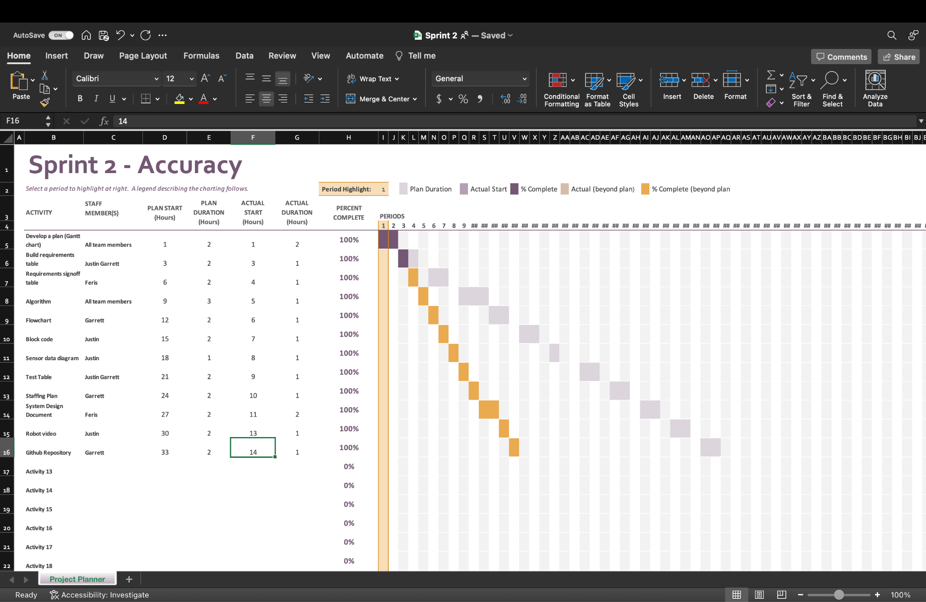

## Staffing Plan

| Name | Role | Responsibility | Reports To |
| --- | --- | --- | --- |
| Justin Veltri | Programmer | Creates algorithm for robot | Justin |
| Garrett Boag | Tester | Tested robot algorithm | Fares/Justin |
| Fares | SDD documentor | Wrote SDD | Fares |